UNIVERSITY INSTITUTE OF COMPUTING

Mini Project

Project Name: Library Management

Program Name: BCA(DS)
Subject: Database Management System
Subject code: 24CAP-204

Submitted by: Submitted to:
Name: Praveen Kumar Name: Suraj Prakash
UID: 24BCD10004 Designation: Asst. Prof.
Section: 24BCD1(A)

Library Management

Aim of the Project:
The main aim of this project is to design and develop a database management system that can efficiently handle and organize all the information related to books, members, and the issue-return process in a library.
It helps in automating library tasks, reducing paperwork, and ensuring data accuracy.

Objective

- To store detailed information about books available in the library.
- To maintain records of registered library members.
- To track which member has borrowed or returned a specific book.
- To prevent duplication and data loss by using a centralized database.
- To provide quick search and retrieval of data using SQL queries.
- To maintain data integrity using keys and relationships between tables.

Tools and Technologies Used

Tool / Technology | Purpose / Description
MySQL / Oracle | To create and manage the database
SQL Language | For writing database queries
MySQL Workbench | For graphical database design and execution
Operating System | Windows 10 / 11
Hardware | Minimum 4GB RAM, i3 Processor
Concepts Used | Primary Key, Foreign Key, DDL, DML, TCL

System Requirements
Hardware Requirements:
- Processor: Intel i3 or above
- RAM: 4 GB minimum
- Hard Disk: 500 MB free space
- Monitor: Standard color display

Algorithm / Logic

- Create database LibraryDB.
- Create three tables — Books, Members, Issue_Return.
- Define BookID and MemberID as primary keys.
- Link Issue_Return with both using foreign keys.
- Insert records of books and members.
- Use SQL queries for:
- Issuing a book (Insert into Issue_Return)
- Returning a book (Update Status and ReturnDate)
- Viewing available books (SELECT query).

Code Overview

CREATE DATABASE LIB;
USE LIB;
CREATE TABLE Books (
BookID INT PRIMARY KEY AUTO_INCREMENT,
Title VARCHAR(100) NOT NULL,
Author VARCHAR(50),
Publisher VARCHAR(50),
Quantity INT
);
CREATE TABLE Members (
MemberID INT PRIMARY KEY AUTO_INCREMENT,
MemberName VARCHAR(100) NOT NULL,
MobileNo VARCHAR(15),
Address VARCHAR(150)
);
CREATE TABLE Issue_Return (
TransactionID INT PRIMARY KEY AUTO_INCREMENT,
BookID INT,
MemberID INT,
IssueDate DATE,
ReturnDate DATE,
Status VARCHAR(20), -- Issued / Returned
FOREIGN KEY (BookID) REFERENCES Books(BookID),
FOREIGN KEY (MemberID) REFERENCES Members(MemberID)
);
INSERT INTO Books (Title, Author, Publisher, Quantity)
VALUES
('DBMS Concepts', 'Korth', 'McGraw Hill', 5),
('Python Basics', 'Guido', 'O\'Reilly', 3),
('AI Revolution', 'Andrew Ng', 'Pearson', 4);

INSERT INTO Members (MemberName, MobileNo, Address)
VALUES
('Praveen Kumar', '9876543210', 'Delhi'),
('Puneet Kaur', '9876500000', 'Chandigarh');
INSERT INTO Issue_Return (BookID, MemberID, IssueDate, Status)
VALUES (1, 2, '2025-10-09', 'Issued');
UPDATE Issue_Return
SET ReturnDate = '2025-10-15', Status = 'Returned'
WHERE TransactionID = 1;
UPDATE Issue_Return
SET ReturnDate = '2025-10-15', Status = 'Returned'
WHERE TransactionID = 1;
SELECT*FROM Issue_Return, Books, Members;

Screenshots/ Output

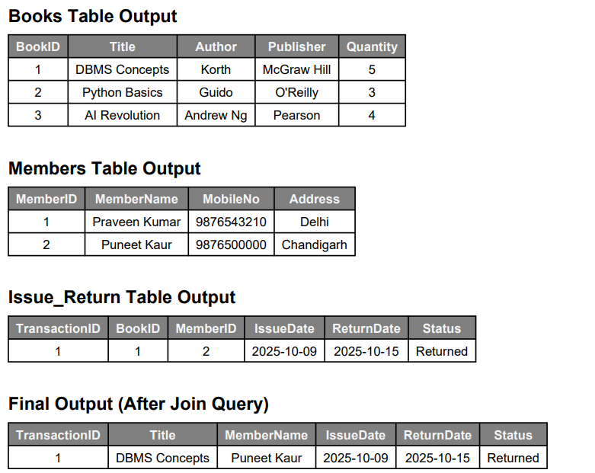

Conclusion:

The Library Management System provides an efficient way to manage library data.
It eliminates manual record keeping, reduces errors, and saves time.
By using SQL and relational database concepts, it ensures data integrity, security, and quick access to information.
It can easily be expanded with a user interface for real-world use.

Learning Outcomes
- Learned how to design normalized database tables.
- Understood how to implement relationships using Primary and Foreign Keys.
- Practiced SQL commands like CREATE, INSERT, UPDATE, JOIN, and SELECT.
- Improved logical and analytical thinking for database design.
- Gained knowledge about real-world DBMS applications.

References
- Database System Concepts — Abraham Silberschatz, Henry F. Korth.
- MySQL Official Documentation: https://dev.mysql.com/doc/
- TutorialsPoint: https://www.tutorialspoint.com/dbms/
- Javatpoint DBMS Notes: https://www.javatpoint.com/dbms-tutorial

